**DAILY ONLINE ACTIVITIES SUMMARY**

|  |  |  |  |  |  |  |  |  |
| --- | --- | --- | --- | --- | --- | --- | --- | --- |
| **Date:** | **29-05-2020** | | | | | **Name:** | **Javahar.S.Goutham** | |
| **Sem & Sec** | **7th b** | | | | | **USN:** | **4AL16CS132** | |
| **Online Test Summary** | | | | | | | | |
| **Subject** | | **Big Data Analysis(BDA)** | | | | | | |
| **Max. Marks** | | **20** | | **Score** | | | **30** | |
| **Certification Course Summary** | | | | | | | | |
| **Course** | **Introduction to Ethical hacking** | | | | | | | |
| **Certificate Provider** | | | **Great Learning** | | **Duration** | | | **6 hrs** |
| **Coding Challenges** | | | | | | | | |
| Problem Statement:   1. Python program to calculate the number of lowercase and uppercase letters in a string. 2. We are given 3 strings: str1, str2, and str3. Str3 is said to be a shuffle of str1 and str2 if it can be formed by interleaving the characters of str1 and str2 in a way that maintains the left to right ordering of the characters from each string. For example, given str1="abc" and str2="def", str3="dabecf" is a valid shuffle since it preserves the character ordering of the two strings. So, given these 3 strings write a function that detects whether str3 is a valid shuffle of str1 and str2. 3. Write a c program to solve a system of linear congruences by applying the Chinese Remainder Theorem. | | | | | | | | |
| **Status: YES, Completed all Programs** | | | | | | | | |
| **Uploaded the report in Github** | | | | | **YES** | | | |
| **If yes Repository name** | | | | | https://github.com/alvas-education-foundation/Goutham-dotcom | | | |

Online Test Details: (Attach the snapshot and briefly write the report for the same)

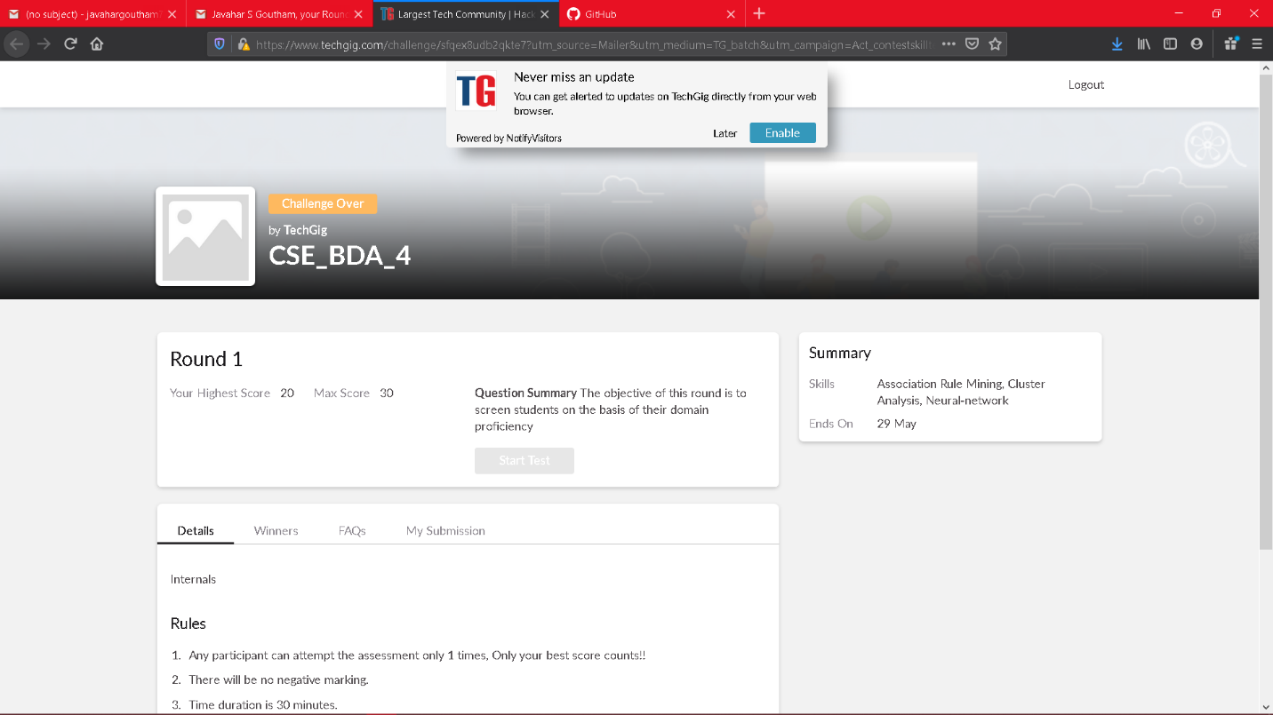

Scored 20 out of 30 in BDA 4I.A test

Certification Course Details: (Attach the snapshot and briefly write the report for the same)

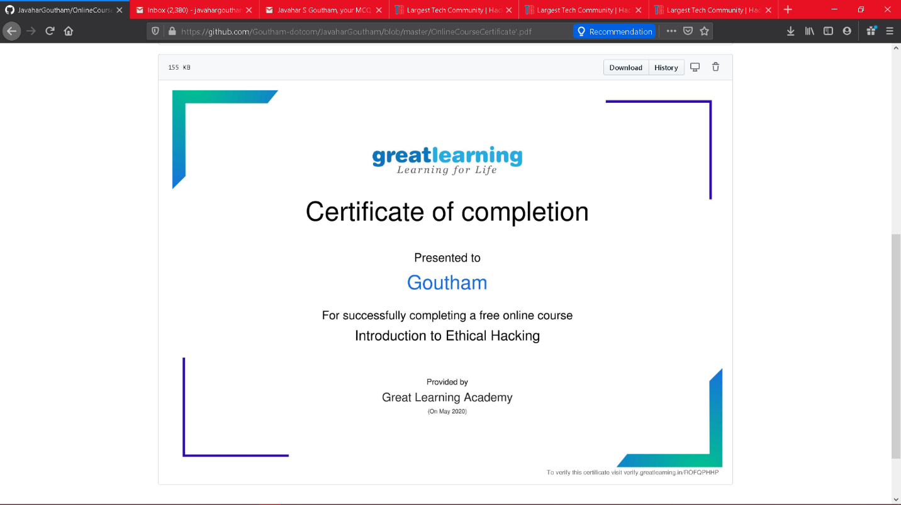

The above course is being taken up by me which is based on the Introduction to ethical hacking The details of the course and certificate provider is mentioned in the above form.

Coding Challenges Details: (Attach the snapshot and briefly write the report for the same)

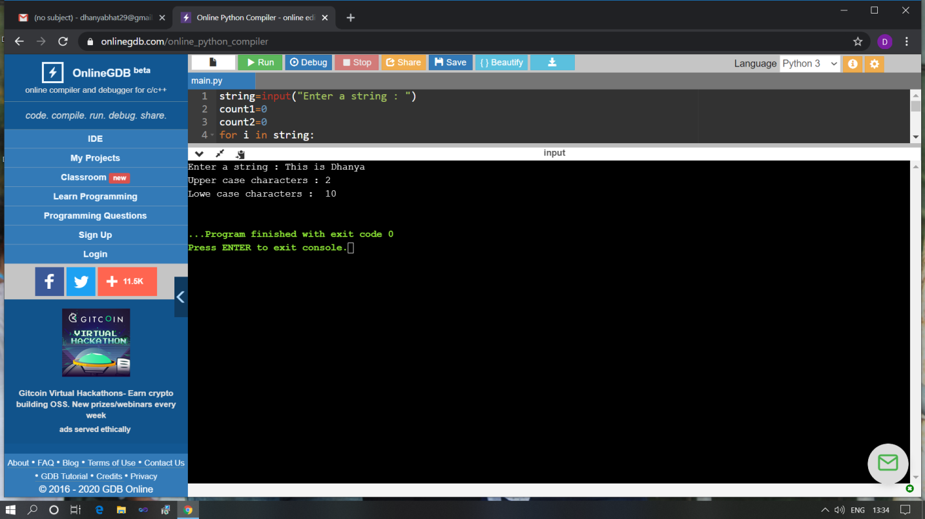

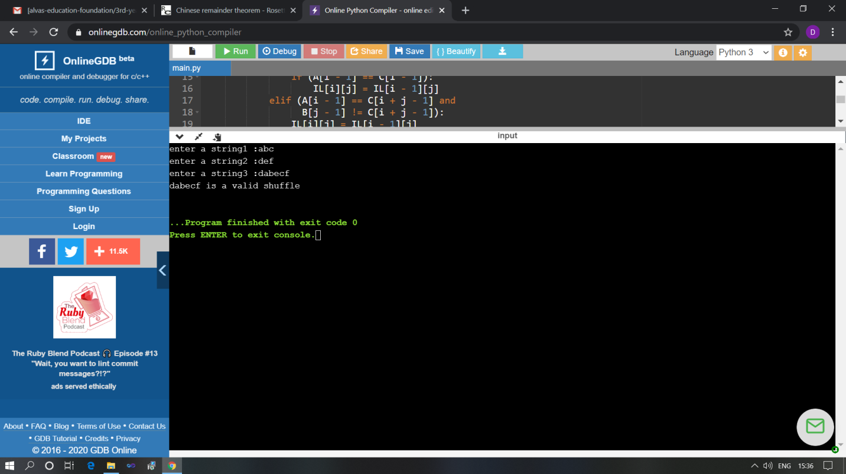

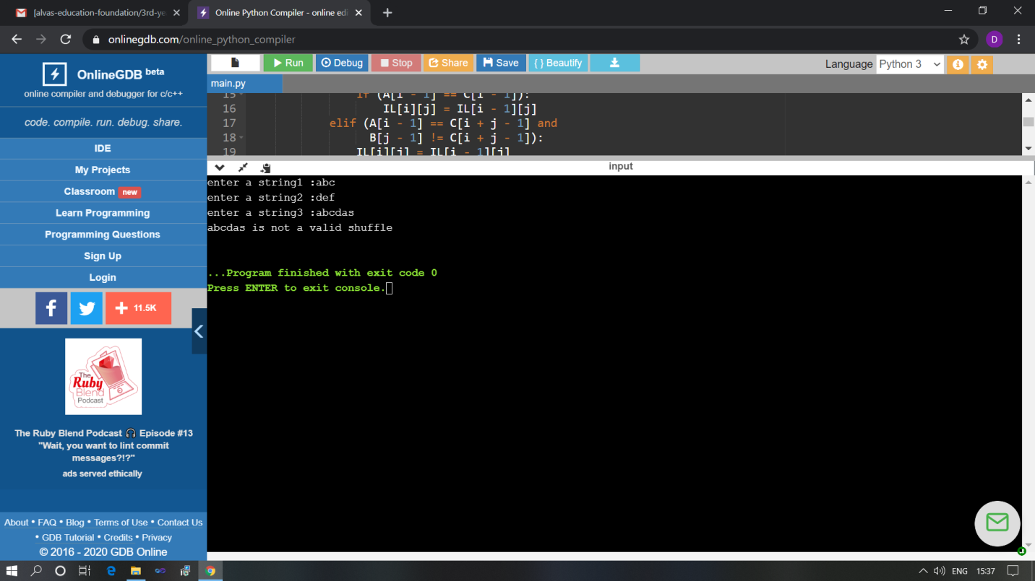

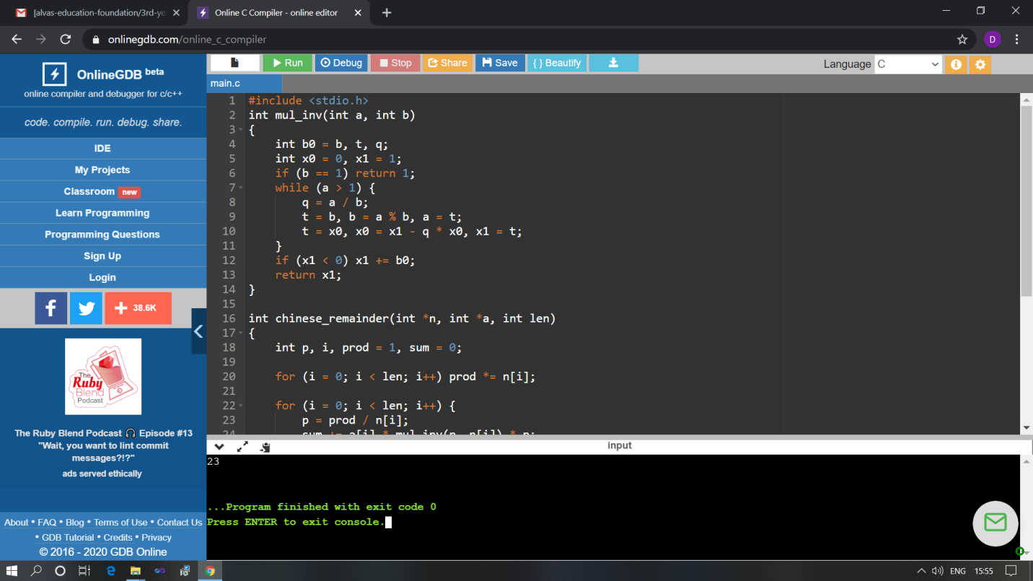

The above Programs were written and executed and the output of the same is displayed above. The code for those 3 programs have been uploaded to the github repository and the link to the same is provided on the form.